**TASK 6 JOIN, RIGHT JOIN AND LEFT JOIN**

1. [SELECT](http://localhost/phpmyadmin/url.php?url=https://dev.mysql.com/doc/refman/8.0/en/select.html) nama, no_telepon, faktur_supply.id_karyawan FROM `faktur_supply` JOIN karyawan ON faktur_supply.id_karyawan = karyawan.id_karyawan ORDER By nama;

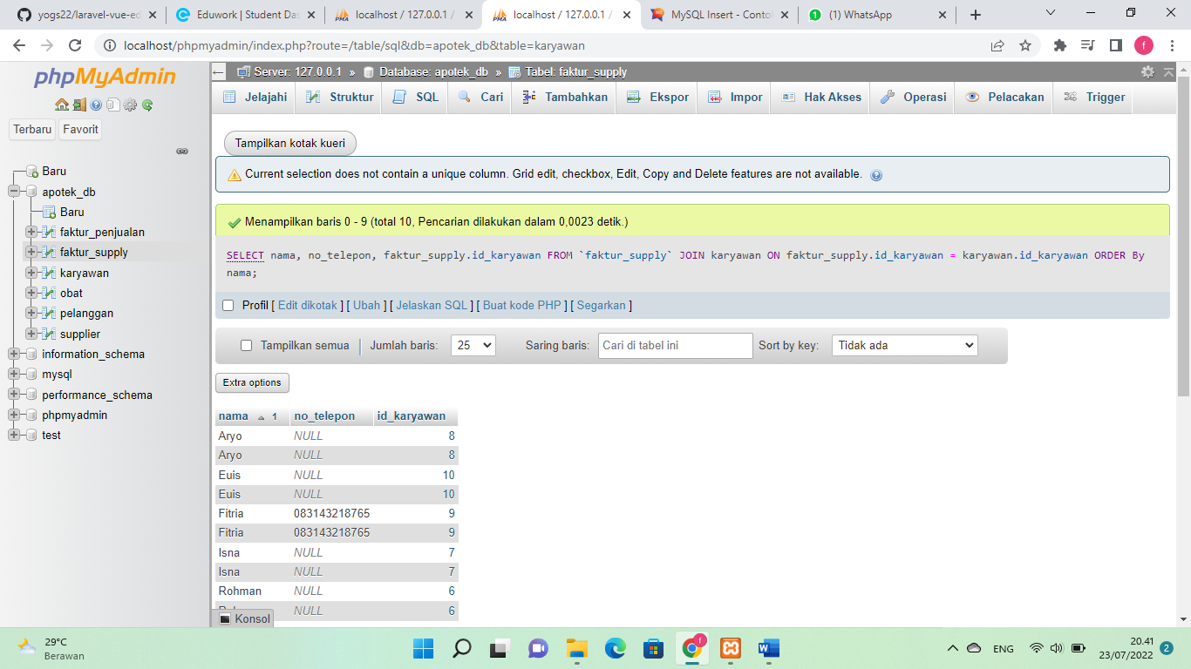

1. [SELECT](http://localhost/phpmyadmin/url.php?url=https://dev.mysql.com/doc/refman/8.0/en/select.html) nama, no_telepon, faktur_supply.id_karyawan FROM `faktur_supply` JOIN karyawan ON faktur_supply.id_karyawan = karyawan.id_karyawan WHERE no_telepon [IS](http://localhost/phpmyadmin/url.php?url=https://dev.mysql.com/doc/refman/8.0/en/comparison-operators.html%23operator_is) [not](http://localhost/phpmyadmin/url.php?url=https://dev.mysql.com/doc/refman/8.0/en/logical-operators.html%23operator_not) null ORDER By nama;

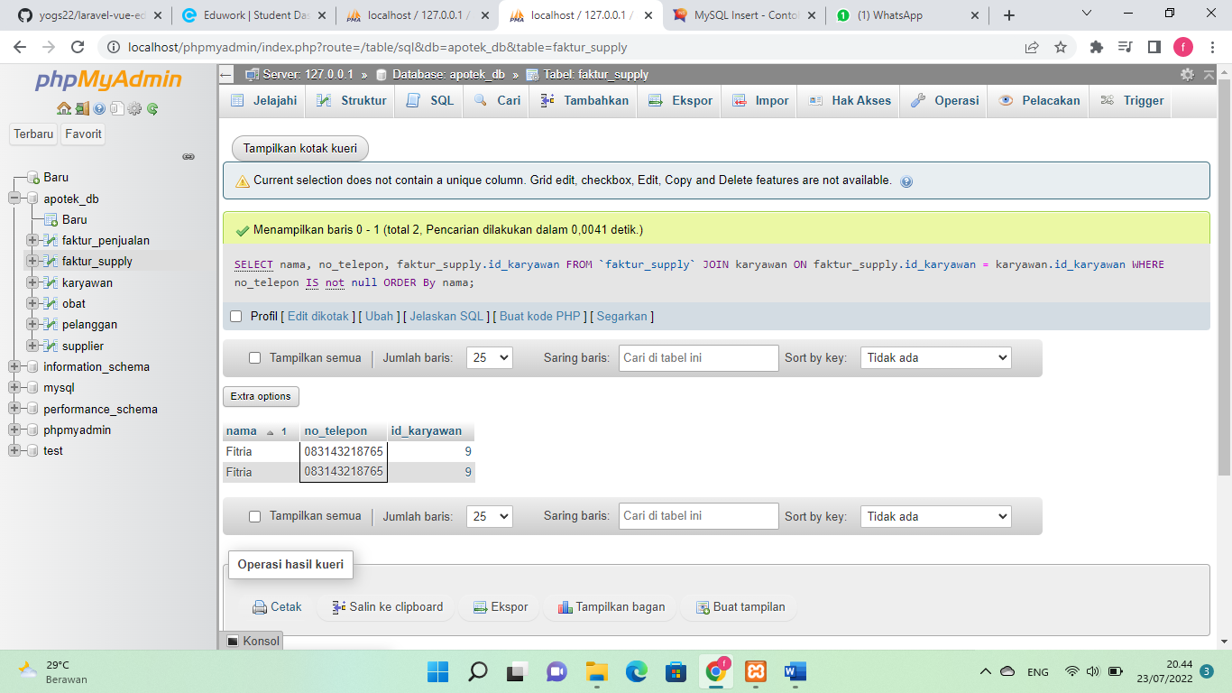

1. [SELECT](http://localhost/phpmyadmin/url.php?url=https://dev.mysql.com/doc/refman/8.0/en/select.html) nama, no_telepon, faktur_supply.id_karyawan FROM `faktur_supply` [RIGHT](http://localhost/phpmyadmin/url.php?url=https://dev.mysql.com/doc/refman/8.0/en/string-functions.html%23function_right) JOIN karyawan ON faktur_supply.id_karyawan = karyawan.id_karyawan WHERE no_telepon [IS](http://localhost/phpmyadmin/url.php?url=https://dev.mysql.com/doc/refman/8.0/en/comparison-operators.html%23operator_is) [not](http://localhost/phpmyadmin/url.php?url=https://dev.mysql.com/doc/refman/8.0/en/logical-operators.html%23operator_not) null ORDER By nama;

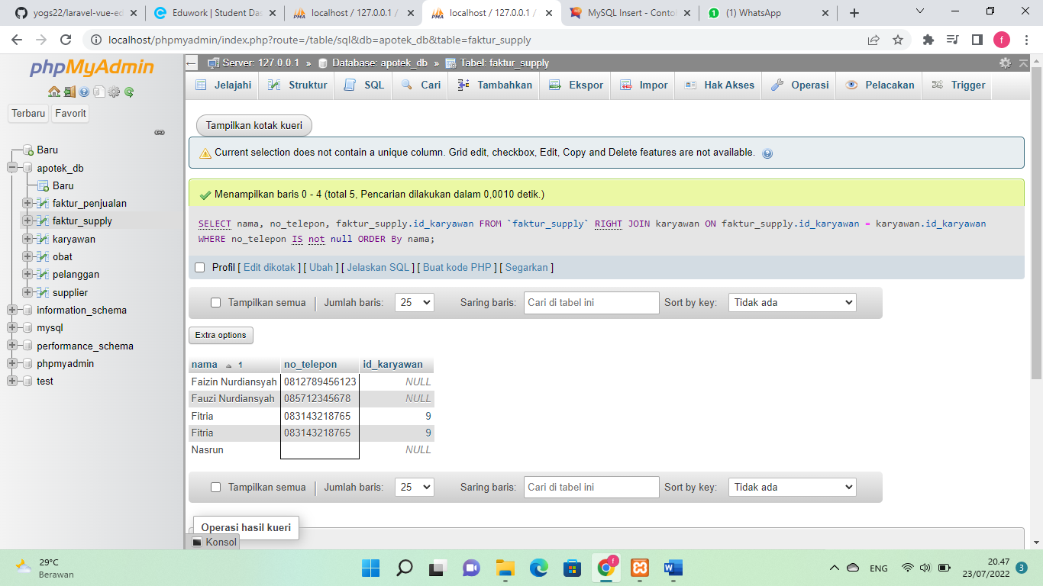

1. [SELECT](http://localhost/phpmyadmin/url.php?url=https://dev.mysql.com/doc/refman/8.0/en/select.html) nama, kota, no_telepon, faktur_supply.id_karyawan FROM `faktur_supply` [LEFT](http://localhost/phpmyadmin/url.php?url=https://dev.mysql.com/doc/refman/8.0/en/string-functions.html%23function_left) JOIN karyawan ON faktur_supply.id_karyawan = karyawan.id_karyawan WHERE kota [LIKE](http://localhost/phpmyadmin/url.php?url=https://dev.mysql.com/doc/refman/8.0/en/string-comparison-functions.html%23operator_like) '%Bekasi%' ORDER By nama;

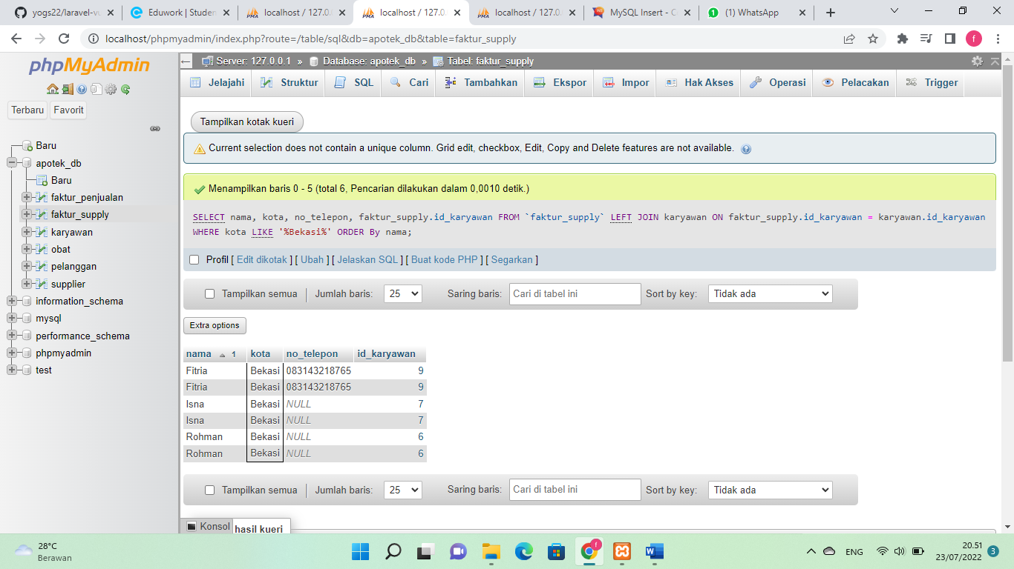

1. [SELECT](http://localhost/phpmyadmin/url.php?url=https://dev.mysql.com/doc/refman/8.0/en/select.html) nama, kota, total_bayar no_telepon, faktur_supply.id_karyawan FROM `faktur_supply` JOIN karyawan ON faktur_supply.id_karyawan = karyawan.id_karyawan WHERE total_bayar >= 130000 ORDER By faktur_supply.id_karyawan ASC;

